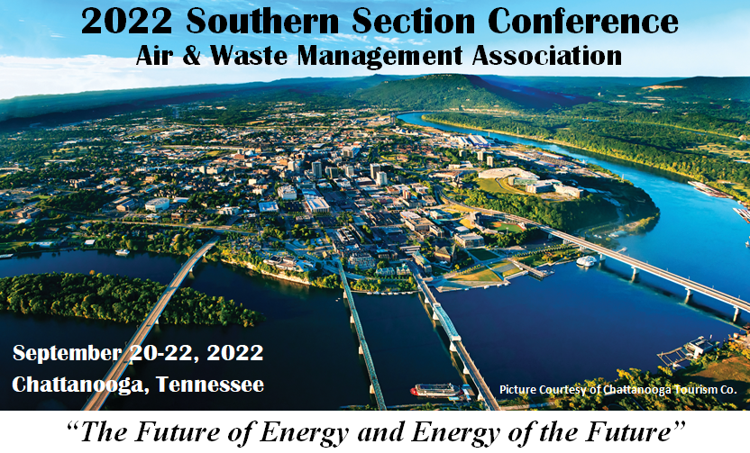

DEAR SPONSOR:

The East Tennessee Chapter of the Southern Section of the Air and Waste Management Association (A&WMA) seeks your involvement in a Corporate Sponsorship Program to improve public awareness on environmental issues and support development of environmental professionals. We believe that, as a participant in this program, your organization will receive substantial benefits by being recognized as progressive, environmentally aware, and concerned about helping your local community.

The Southern Section covers the State of Alabama, Georgia, Mississippi, and Tennessee. The Southern Section will hold its 2022 Conference on September 20 – 22, 2022 at the Downtown Doubletree in Chattanooga, Tennessee.

There are several corporate and individual sponsorship levels available associated with the 2022 Southern Section Annual Conference as follows:

- College Scholarship Sponsor - $1,500 (each) -Two scholarships *
- Bronze Level Sponsor - $250: - 3 to 5 different activities
- Silver Level Sponsor - $500: - Refreshments for four breaks
- Gold Level Sponsor - $1000 (includes one registration): - Two Luncheons
- Platinum Level Sponsor - $2000 (includes two registrations): - Evening reception

* The Southern Section of A&WMA is a private, non-profit 501(c)(3) organization.

Our all-volunteer organization anticipates using the proceeds from the Corporate Sponsorship Program for the following activities:

• Providing scholarships for college students pursuing environmentally oriented degrees in Southern Section.
- Funding technical outreach activities of the Southern Section

An enrollment form is enclosed for your use in joining the program. Simply complete the form and return it with your check made out to of A&WMA Southern Section or a copy of your online payment receipt. If you have any questions about the program, please contact Richard Wales at 760-964-0872 or RTWales2014@gmail.com.

Sincerely,
Richard Wales, Conference Chair
A&WMA East Tennessee Chapter

APPLICATION FOR SPONSORSHIP
2022 Annual Southern Section A&WMA 3-day Conference
September 20-22, 2022

Sponsoring Organization: ___________________________________

Sponsoring Level:
Please check the level of sponsorship you are interested in below:

College Scholarship Sponsor - $1,500 (each) Two scholarships will be awarded at the 2022 Southern Section Conference*.
One Scholarship: Two Scholarships:

Bronze Level Sponsor - $250:
Student/YP Event (TBD) ___, Social Activity/Outing (TBD) ____
Speaker Gifts Printing Cost General

Silver Level Sponsor - $500:
Morning break (9/21) ____ (9/22) ____
Afternoon break (9/20) ___ (9/21) ____

Gold Level Sponsor - $1000 (includes one registration):
Luncheon (9/21) ____, Luncheon (9/22) ____

Platinum Level Sponsor - $2000 (includes two registrations):
Evening Networking Reception (9/20) ____

Sponsoring Organization Address:
Mailing Address: ___________________________________
___________________________________
Company Website: ___________________________________
Sponsor Contact: ___________________________________
Email Contact: ___________________________________
Phone Number: ___________________________________

* The Southern Section of A&WMA is a private, non-profit 501(c)(3) organization.

Payment Information (check one): Check Credit Card
To pay via credit card, please visit the following link: https://www.ss-awma.org/2022-annual-meeting.html
To pay via check, make checks payable to Southern Section A&WMA and mail in with this from to:
Mr. Richard Wales
6154 McMillan Creek Drive
Knoxville, TN 37924-5500

Hotel reservations must be made through the DoubleTree no later than August 20th by going to https://www.hilton.com/en/attend-my-event/chachdt-awm-be5a3523-4202-4bb0-992a-aa78ed76bbb8/ Rooms are available for $109 plus taxes

Please Email Company Logo to: rtwales2014@gmail.com

